Curriculum Policy
2019 – 2020
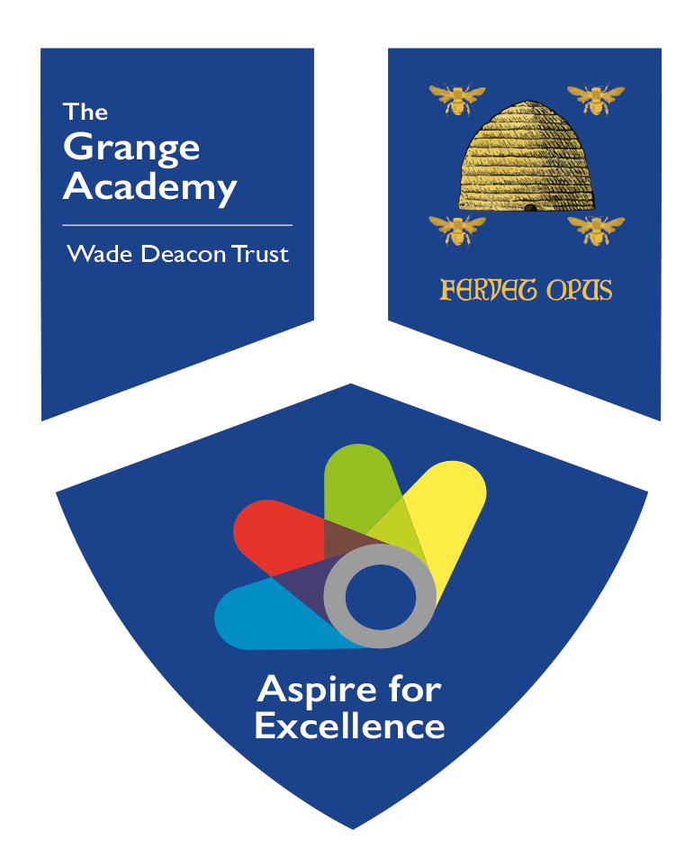
Version Number: 02
Ratified by Local Governing Body: September 2019
Next Review Due: September 2020
School Link: Mrs J Thomson

What is the purpose of our curriculum? (Intent)
Our ‘all-through’ curriculum is designed to meet the needs of students from the ages 3-16 to ensure we create well-rounded students that are fully prepared for life beyond The Grange Academy. The National Curriculum is covered and students cover a rich and balanced curriculum across all the phases. We match our curriculum to the abilities, interests and aspirations of our students, to give every child the opportunity to aspire for excellence. We value the contribution that creative, practical and vocational learning brings to a child’s development alongside the traditional academic subjects. Our aim is to create well-rounded students that are fully prepared for their life beyond The Grange Academy.

How will it be taught? (Implementation)
Through our unique PACE Curriculum students will be given the opportunity the express their knowledge, skills and understanding though Participation, Application, Communication & Exploration. The PACE framework

Participation | Engagement  Good attitude to learning  Pupils playing an active role.  Development of speaking and listening skills.  Team work  Perseverance
Examples: no hands up, lollipop sticks, raffle tickets, challenges on board at start of lesson, valuing opinions of others, active reading together, competitions, challenges, pair work, group work, Kagan groups, mixed ability, teaching each other, bringing in work from home.

Application | Demonstrate learning, remember, understand, applying knowledge to a range of tasks, use same skills across subjects, links to other subjects, links to real life experiences, proof of learning
Examples make a song or rap, demonstrate learning through a song, rap, poster, performance, gallery, debate, read stories to others, invite parents to share learning, invite a guest, make a book, competitions, email, letter to famous or important people

Communication | Presentation of self and work, use of voice, tone, volume, pitch, management of self, adapt behaviour for different roles, vocabulary (Word of the Week), listening attentively, expressing opinion, emotion and ideas, articulate
Examples talking partners, modelled speaking and listening, sentence starters (all subjects), social situations and role play, turn taking, the art of conversation, different reasons and styles of communication, standard and non-standard English, body language, eye contact

Exploration | Investigate  Independent thinker  Question  Research  Create, problem solve, analyse, evaluate, be inquisitive
Art, Music, Drama, the world around, issues in society, think outside the box, culture, sports, the news, it is OK to get things wrong, technology, the world of work

Impact

In the Primary phase the impact of the curriculum is monitored through assessment, pupil and parent voice. Assessments are based on the content taught. Staff assess whether pupils have understood the year group expectations in that subject and to what extent they have been able to use the knowledge and apply the skills taught. Pupils who can independently demonstrate understanding with little support are assessed as working at the expected standard, pupils who can then apply the knowledge and use the skills in a wide range of contexts are assessed as working at Greater Depth, pupils who need a great support but with this support and scaffolding can demonstrate understanding are assessed as working towards the expected standard and pupils who have work altered and based on previous year group objectives are assessed as working below the expected standard. These pupils are usually on the SEND register or being assessed to understand their needs.

Curriculum Champions monitor the impact of the curriculum through looking at learning in books, lessons, through talking to pupils and staff and through analyzing assessments. Senior Leaders oversee the curriculum champions so that any CPD required can be identified and provided to appropriate or all staff.

In the Secondary phase the impact of the curriculum is also monitored through assessment, which are cumulative in nature and test the knowledge of the content taught to date. All students in each year group are assessed through both classwork and formal assessments, which are communicated to parents twice throughout the year. This communication includes a Grade Card containing the grade or level achieved in the relevant assessment and the level of progress towards their milestone target. Additionally, a behavior and effort grade for each subject is awarded. There is a further opportunity for all parents to meet with school teachers at Progress Evenings.

Through a quality assurance review process, subject/faculty leaders monitor the impact of the curriculum through regular meeting cycles other schools in the Trust, their team and SLT, book scrutiny, lesson observations and through talking to students and staff to monitor appropriateness and rigour of assessments. CPD requirements are identified and put in place for all staff.

Curriculum Overview 2019 - 2020

Opportunities for all
The Grange Academy has high expectations for all students and a commitment to excellence. We provide a broad and balanced curriculum which fulfils the requirements of the National Curriculum and enables students to realize their full potential through the provision of personalised curriculum pathways.
From Nursery to Year 6, every student’s achievement is continually assessed in all subjects. Progress and attainment is evaluated and reported to parents in the form of 1:1 meetings twice a year and through an end of year report to parents. Regular meetings take place with parents for learner’s of concern. Pupil progress is discussed each half term. Statutory assessments take place in Reception, Year 1(phonics), Year 2 and Year 6.
From years 7 to 11, every student’s achievement is continually assessed and at the end of each phase of assessments, their progress and attainment is evaluated and reviewed with a Grade Card being sent to parents and carers. Every child will begin their GCSE courses in Year 9 and complete them over three years, being examined in year 11.
If a student is keen and enthusiastic about music and would like to learn to play a musical instrument, the school will offer this provision which will be timetabled during the school day. If this opportunity is taken, please be aware that the school would appreciate your support in ensuring that 100% of the peripatetic lessons are attended and that your child will be expected to perform, with others, at a variety of school events.

Objectives:
Objectives that relate to the curriculum aims of The Grange Academy are:
- That students should become aware of their abilities, thus develop them to their maximum potential.
- That students should be aware of the needs of the community and be prepared to contribute fully to the life of the community.
- That all students should be offered a curriculum that has breadth and depth. It must be tailored to each student and satisfy their requirements.
- That students who leave The Grange Academy should be articulate, literate and numerate, and have lively, enquiring, independent minds.
- That students who leave The Grange Academy should:
  - be confident in their dealings with adults and peers.
  - be able to develop good working relationships with others.
  - have knowledge of a wide range of cultures and through this come to respect the rights and needs of others.
  - be able to make good moral judgements.
  - have developed a love of learning that will last for the rest of their lives.
  - be adaptable enough to react to the needs of a fast changing world.

Curriculum Model:
The present model in primary is mostly based on a one week, 25 hour timetable. Some year groups follow a 2 week cycle due to PPA lessons. In EYFS continuous provision is used alongside focused teaching inputs
The present model in secondary is based on a two week, 50 one-hour lesson timetable.

EYFS:

EYFS at The Grange starts at the age of 3 with Nursery provision. Pupils begin Nursery the term after they turn 3 years old. Some pupils attend for 30 hours a week whilst others 15 hours. The Curriculum is theme based but is also responsive to the children’s interests. Learning and topics are both teacher designed and child initiated. Discrete phonics and number is taught daily. Read Write Inc and Letters and Sounds schemes are used to deliver phonics. Opportunities are provided in all EYFS areas of learning and are continually assessed. Assessments are reported to parents daily through an online assessment tool (currently Tapestry). Parents contribute to assessments by sharing home learning activities with staff. Maths is taught with a focus on a number a week and through shape space and measure activities.

Key Stage 1:

Year 1 and 2 follow the National Curriculum. Topics are designed using Concepts as a theme e.g care, hope, courage. These link the subjects together. A text base approach is used in English. Investigation, reasoning and discussion are key elements to the curriculum as is a real reason to learn. Topics all have an aim and a link to the world around the pupils e.g a visit to the local area, a shared learning experience with another class, a presentation to parents or the local old people’s home. Phonics is taught as a discrete lesson each day. Read Write Inc and Letters and Sounds are used to deliver phonics. The main Reading scheme used is Oxford Reading Tree but it is supplemented with other books to provide depth and breath. Maths is taught using the Power Maths Scheme. This encourages problem solving, discussion and reasoning. Lessons length varies from 30 minutes to 1 hour and include Maths, English, Phonics, Science, Geography, History, PE, Music, Computing, Art, DT, SMSC, Arithmetic, SPaG, RE, MfL, Vocabulary and class reading

Key Stage 2:

Years 3 to 6 follow the National Curriculum. Topics are designed using Concepts as a theme e.g care, hope, courage. These link the subjects together. A text base approach is used in English. Investigation, reasoning and discussion are key elements to the curriculum as is a real reason to learn. Topics all have an aim and a link to the world around the pupils e.g a visit to the local area, a shared learning experience with another class, a presentation to parents or the local old people’s home. Reading for comprehension is taught and a range of scheme books are used depending on the aility and need of pupils. In Years 5 and 6 pupils use Accelerated Reader. Maths is taught using the Power Maths Scheme. This encourages problem solving, discussion and reasoning. Pupils are prepared for tests by learning test techniques so that they understand how to tackle questions. We test pupils using NFER and SATs based tests. Lessons range in length from 30minutes to 1 hour and include Maths, English, Phonics, Science, Geography, History, PE, Music, Computing, Art, DT, SMSC, Arithmetic, SPaG, RE, MfL, vocabulary and class reading

Key Stage 3:
Key Stage 3 (Year 7 and 8) is a very challenging yet enjoyable phase in our students’ school career. Your child will be prepared, academically and socially during this time to enable them to achieve their potential in their GCSE years and beyond. We will build upon and further develop skills of literacy, numeracy, analysis and evaluation to create students who are independent and can approach their studies with creativity and originality.
Year 7 | English | Maths | Science | MFL | Geog | Hist | PE | Comp | DT | Art | Music | Drama | RE | Total
 | 8 | 8 | 7 | 4 | 4 | 4 | 4 | 2 | 2 | 2 | 2 | 2 | 1 | 50
 | 16 | 16 | 14 | 8 | 8 | 8 | 8 | 4 | 4 | 4 | 4 | 4 | 2 | 100
Year 8 | English | Maths | Science | MFL | Geog | Hist | PE | Comp | DT | Art | Music | Drama | RE | Total
 | 8 | 8 | 7 | 4 | 4 | 4 | 4 | 2 | 2 | 2 | 2 | 2 | 1 | 50
 | 16 | 16 | 14 | 8 | 8 | 8 | 8 | 4 | 4 | 4 | 4 | 4 | 2 | 100

Student Setting:
In both year 7 and 8, students may be placed into sets according to performance and progress at KS2 and in assessments. There are two formal assessment points within the year which allow for this.
The required completion of linear GCSE examinations means that progress and attainment during KS3 is fundamental to achievement in year 11. Heads of Faculty and class teachers provide a challenging curriculum in every subject that prepares students with the knowledge, understanding and skills of how to learn and also the skills which are needed for the future.
Primary transition involves close liaison between Ms McPartland (Associate Principal), Mr Beavon (Progress Leader for Year 6, 7 and 8) and primary school teachers. This enables early identification of individual needs in order to maintain academic momentum, thus ensuring a smooth, yet challenging start in secondary school.
At The Grange Academy, using KS2 SATs results, we have our own target setting methodology that sets accurate and challenging ‘Targets’ we hope that not only do students achieve their target grade but they achieve much more. Target grades may be reviewed if a student achieves their grade to ensure further stretch and challenge.

Key Stage 4:

Option opportunities:
There are two curriculum pathways that run in years 10 and 11, the Baccalaureate Pathway and the Success Pathway. In year 9, we have introduced an additional Creative Pathway.

Baccalaureate Pathway
This will enable students to achieve the English Baccalaureate qualification. A student must attain Grades 4 or 5 and above in all GSCE subjects listed below:
- English Language
- English Literature
- Mathematics
- Science (at least 2 GCSEs)
- History or Geography
- French or Spanish
- 2 other option subjects
- Physical Education
- Students will also continue to follow our SMSC programme which includes Religious Studies and Careers

Success Pathway
Students on the Success Pathway will follow:
- English Language and English Literature
- Mathematics
- Trilogy Science (at least 2 GCSEs)
- History or Geography
- 2 other options subjects
- Physical Education
- Students will also continue to follow our SMSC programme which includes Religious Studies and Careers

Creative Pathway – Year 9 only
The Creative Pathway includes the Creative I-Media course which develops students’ skills in ICT, Web Design and Multi-Media. The aim of this course is to ensure your child is computer literate and is prepared fully for a thriving creative industry. The intention is that this course would be completed by the end of Year 10 which may allow students to be supported with additional time in the core subjects in Year 11.
Students will study the following courses during Years 9 – 11.

- English Language
- English Literature
- Mathematics
- Science: Double Award (2 GCSEs)
- Creative I-Media
- Physical Education* (Course choices will be in consultation with PE Staff)
- 2 other options subjects
- Students will also continue to follow our SMSC programme which includes Religious Studies and Careers

Time allocations:
Allocation for subjects within individual year groups (in hours) is as follows:

Key Stage 4:

Year 9 options subjects/lesson number: (see option forms below)
Year 9 | Lang & Lit | Maths | Science x 2 | PE | Ebacc Opt 1 | Opt 2 | Opt 3 | SMSC | Total
 | 9 | 9 | 9 | 5 | 6 | 6 | 6 |  | 50
 | 18 | 18 | 18 | 10 | 12 | 12 | 12 | 0 | 100

Year 10 options subjects/lesson number:
Year 10 | Lang & Lit | Maths | Science x 2 | PE | Ebacc Opt 1 (A) | Opt 2 (B) | Opt 3 | SMSC | Total
 | 10 | 10 | 8 | 4 | 6 | 6 | 6 | 0 | 50
 | 20 | 20 | 16 | 8 | 12 | 12 | 12 | 0 | 100

Option Choices

Art, Business Studies, Childcare, Hospitality and Catering, Photography, I Media, Design Technology, Music, Sports Studies.

Year 11 options subjects/lesson number:
Year 11 | Lang & Lit | Maths | Science x 2 | Ebacc | Pool A | Pool B | Pool C | PE | Total
 | 8 | 8 | 8 | 6 | 6 | 6 | 6 | 2 | 50
 | 16 | 16 | 16 | 12 | 12 | 12 | 12 | 4 | 100

Option Choices

Art, Business Studies, Hospitality and Catering, Photography, Hospitality and Catering, Design Technology, I Media, Media Studies, Music, GCSE PE/Sports Studies.
* Please Note: the selection of courses may change owing to new developments in qualifications over time.

Year 9 Options – Baccalaureate and Success

Student Name…………………………………..Tutor Group…………
Student Signature………………………………………………………...
Parental Signature……………………………………………………….
The English Baccalaureate (Ebacc)
The English Baccalaureate is a suite of subjects that consist of the following: English, mathematics, two sciences, a modern foreign language and history or geography. Successfully achieving in this combination of GCSEs contributes to achieving the Ebacc measure. The combination of these subjects may be sought after by certain universities and this broad balance of subjects provides an excellent platform for further and higher qualification routes. Therefore, on the options form it would be necessary to pick a Modern Foreign Language (French) and a Humanities subject (History or Geography).

Compulsory Subjects
Students will study the following courses during Years 9 – 11.

- English Language
- English Literature
- Mathematics
- Science - (Course choices will be in consultation with Science Staff)
Science Double Award (2 GCSEs) / Separate Science - (3 GCSEs)
- Physical Education* (Course choices will be in consultation with PE Staff)
- Students will also continue to follow our SMSC programme which includes Religious Studies and Careers

* Physical Education Pathways | Choice (Tick 1)
GCSE PE – (One GCSE)
Sports Studies – (One GCSE)
Performing Arts / Dance – (One GCSE)
Core PE – No qualification attached to this pathway

The Physical Education Pathway ensures that students can access physical activity and learn about healthy and active lifestyles which we believe are essential life skills. This will also support the health and well-being of students as they prepare for their GCSEs.

Option One

You must choose (tick) one from this list
French (GCSE) or History (GCSE) or Geography (GCSE)

Further Options

Please choose a further four subjects from the list below (you will study two of these);
My four choices in order of preference are:
 | 1st Choice  (Tick 1) | 2nd Choice  (Tick 1) | 1st Reserve  (Tick 1) | 2nd Reserve  (Tick 1)
History
Geography
French
ICT (Creative I-Media)
Drama
Photography
Music
Business Studies
Design Technology
Hospitality & Catering
Art
Child Development

Students should consider the most appropriate options based on their progress, attainment, interest and also their potential future careers. Please refer to the options handbook, which can be found on the school website (www.thegrange.com) for subject specific information. Please be aware that courses will only take place if there are a viable number of students that opt for that particular subject. Please Note: Whilst we will always aim to ensure students can take their preferences due to the constraints of timetabling and teacher capacity this may not always be possible.

Year 9 Options - Creative

Student Name…………………………………..Tutor Group…………
Student Signature………………………………………………………...
Parental Signature……………………………………………………….
The Creative Pathway

The Creative Pathway includes the Creative I-Media course which develops students’ skills in ICT, Web Design and Multi-Media. The aim of this course is to ensure your child is computer literate and is prepared fully for a thriving creative industry. The intention is that this course would be completed by the end of Year 10 which may allow students to be supported with additional time in the core subjects in Year 11.
Compulsory Subjects
Students will study the following courses during Years 9 – 11.

- English Language
- English Literature
- Mathematics
- Science: Double Award (2 GCSEs)
- Creative I-Media
- Physical Education* (Course choices will be in consultation with PE Staff)
- Students will also continue to follow our SMSC programme which includes Religious Studies and Careers

* Physical Education Pathways | Choice (Tick 1)
GCSE PE – (One GCSE)
Sports Studies – (One GCSE)
Performing Arts / Dance – (One GCSE)
Core PE – No qualification attached to this pathway

The Physical Education Pathway ensures that students can access physical activity and learn about healthy and active lifestyles which we believe are essential life skills. This will also support the health and well-being of students as they prepare for their GCSEs.
Options

Please choose four subjects from the list below (you will study two of these);
My four choices in order of preference are:
 | 1st Choice  (Tick 1) | 2nd Choice  (Tick 1) | 1st Reserve  (Tick 1) | 2nd Reserve  (Tick 1)
History
Geography
Drama
Photography
Music
Business Studies
Design Technology
Hospitality & Catering
Art
Child Development

Students should consider the most appropriate options based on their progress, attainment, interest and also their potential future careers. Please refer to the options handbook, which can be found on the school website, for subject specific information. Please be aware that courses will only take place if there are a viable number of students that opt for that particular subject. Please Note: Whilst we will always aim to ensure students can take their preferences due to the constraints of timetabling this may not always be possible.

